n October 5, 2025, I had the opportunity to interview Arielle Jasmine E. Yao, a talented local photographer. The interview took place at Cafe Tizan, Cabagnan, Legazpi, where we spent the evening discussing her journey, inspirations, and challenges as a young artist.

I have known Arielle personally since our freshman years when we both discovered a shared interest in photography. Over time, that common passion turned into collaboration, we became partners in crime (photographers) during our time as Junior Councilors at our College Student Council last year. Together, we covered various college events, capturing moments that brought out the heart and energy of our college.

Having witnessed her dedication firsthand, I wanted to learn more about the person behind the lens. What follows is an intimate look into Arielle’s artistic journey, her evolution as a photographer, and her reflections on how photography allows her to freeze moments that tell stories.

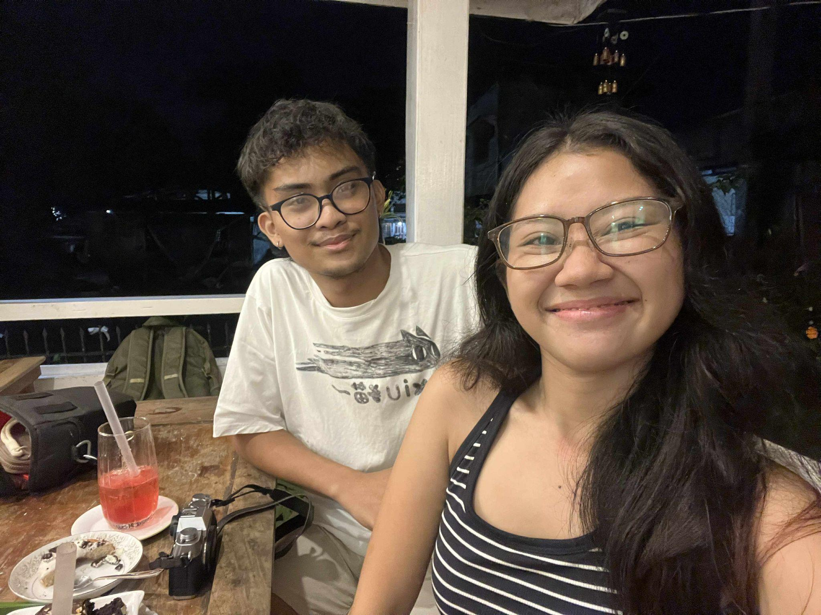

**Cafe Tizan, October 5, 2025**

**Quick look at our interview setting**

From the municipality of Libmanan, Camarines Sur, emerges a young artist whose lens transforms everyday scenes into time capsules. Arielle Jasmine E. Yao, a third-year BS Chemistry student at Bicol University College of Science, is a self-taught photographer whose path began not in a formal studio, but through genuine curiosity.

Arielle’s artistic path started in 2018, when she found herself surrounded by friends who were active in photography and journalism. Their enthusiasm sparked her interest, leading her to pick up a camera and begin experimenting with film making. She was drawn to the tone and vibe of analog film. This experience would later influence her photography style, which is now defined by a vintage and nostalgic look, reminiscent of film.

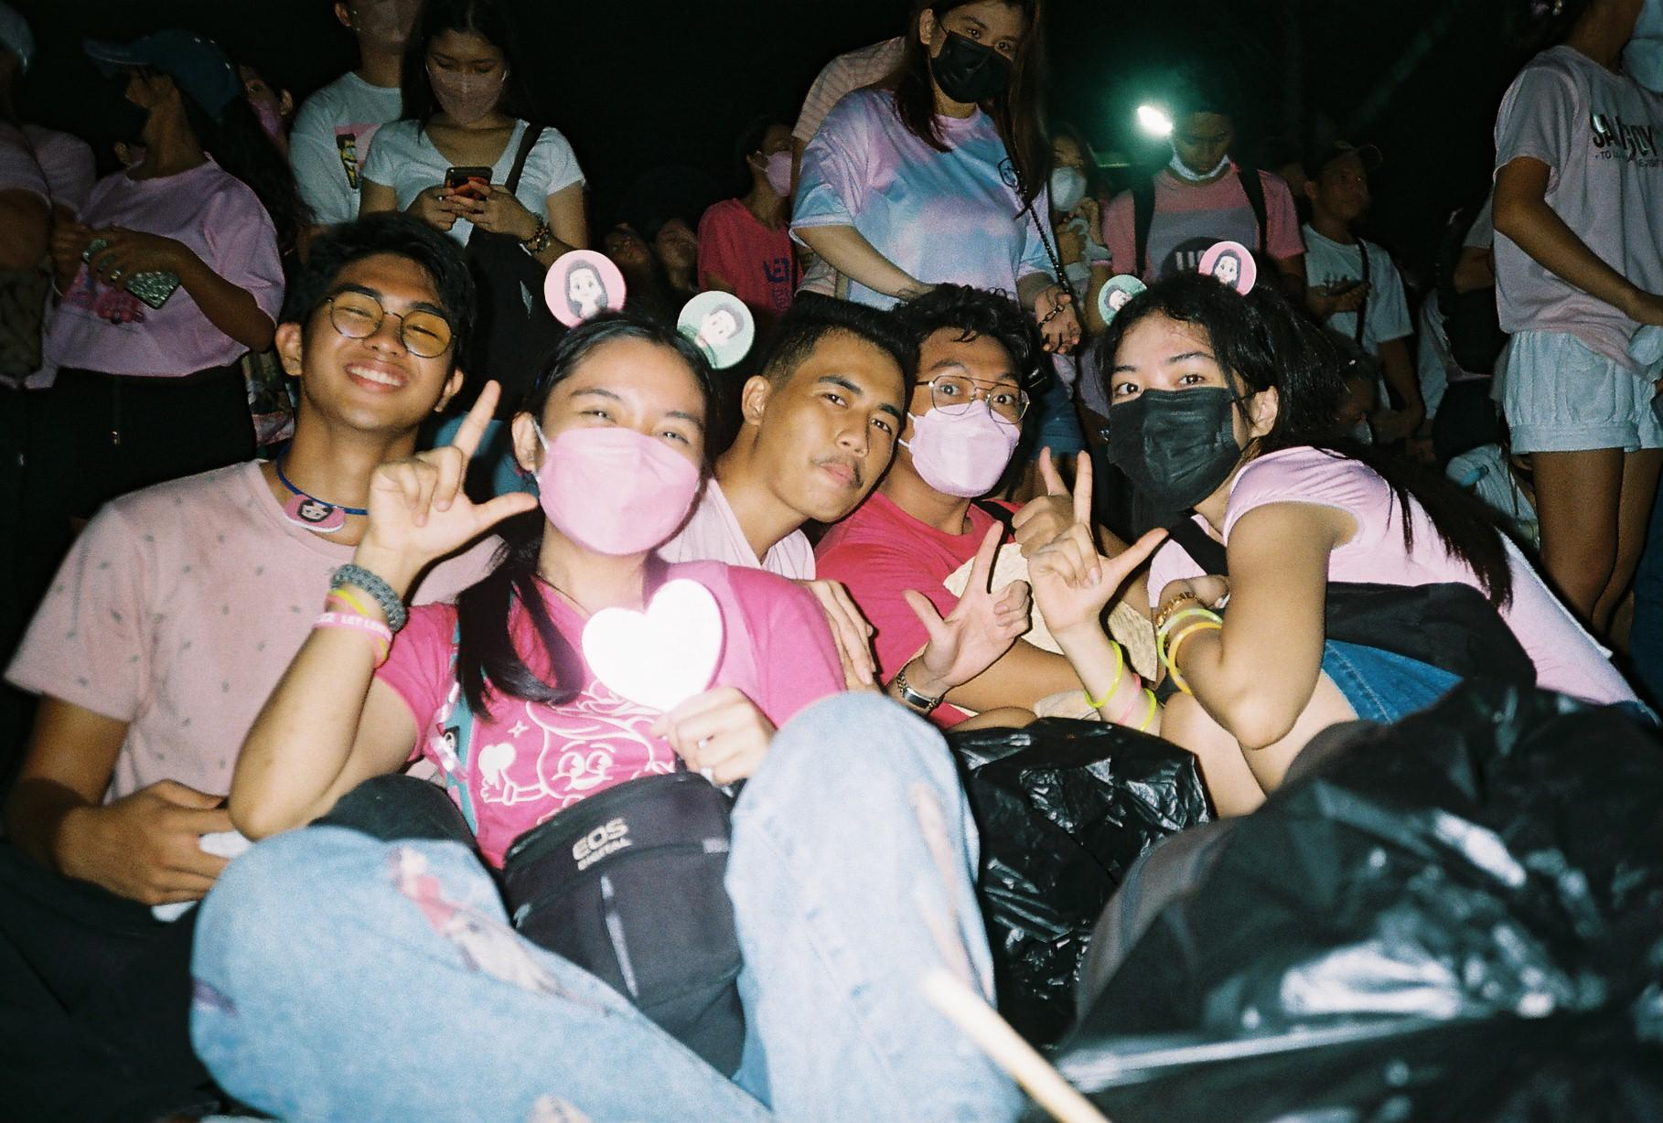

**Leni Kiko Rally, 2022**

**Olympus AM-100**

**Celebrates her volunteer spirit and collective action with friends.**

Over the years, her dedication to the craft has opened many doors for her to grow and connect with others. She has participated in online and school photography competitions, using each opportunity to challenge herself and develop new techniques. Her first official photography gig came shortly after the pandemic, a debut shoot that served as her introduction to professional work. That project became a pivotal moment in her artistic journey, boosting her confidence and ability to work under real-world conditions.

Encouraged by that experience, Arielle took on a larger role by serving as one of the official photographers for the College of Science, College Student Council. This role not only tested her technical skills but also taught her the importance of teamwork, patience, and adaptability. Her exposure to real events further strengthened her artistic perspective, showing her that every picture can capture emotion as much as it tells stories.

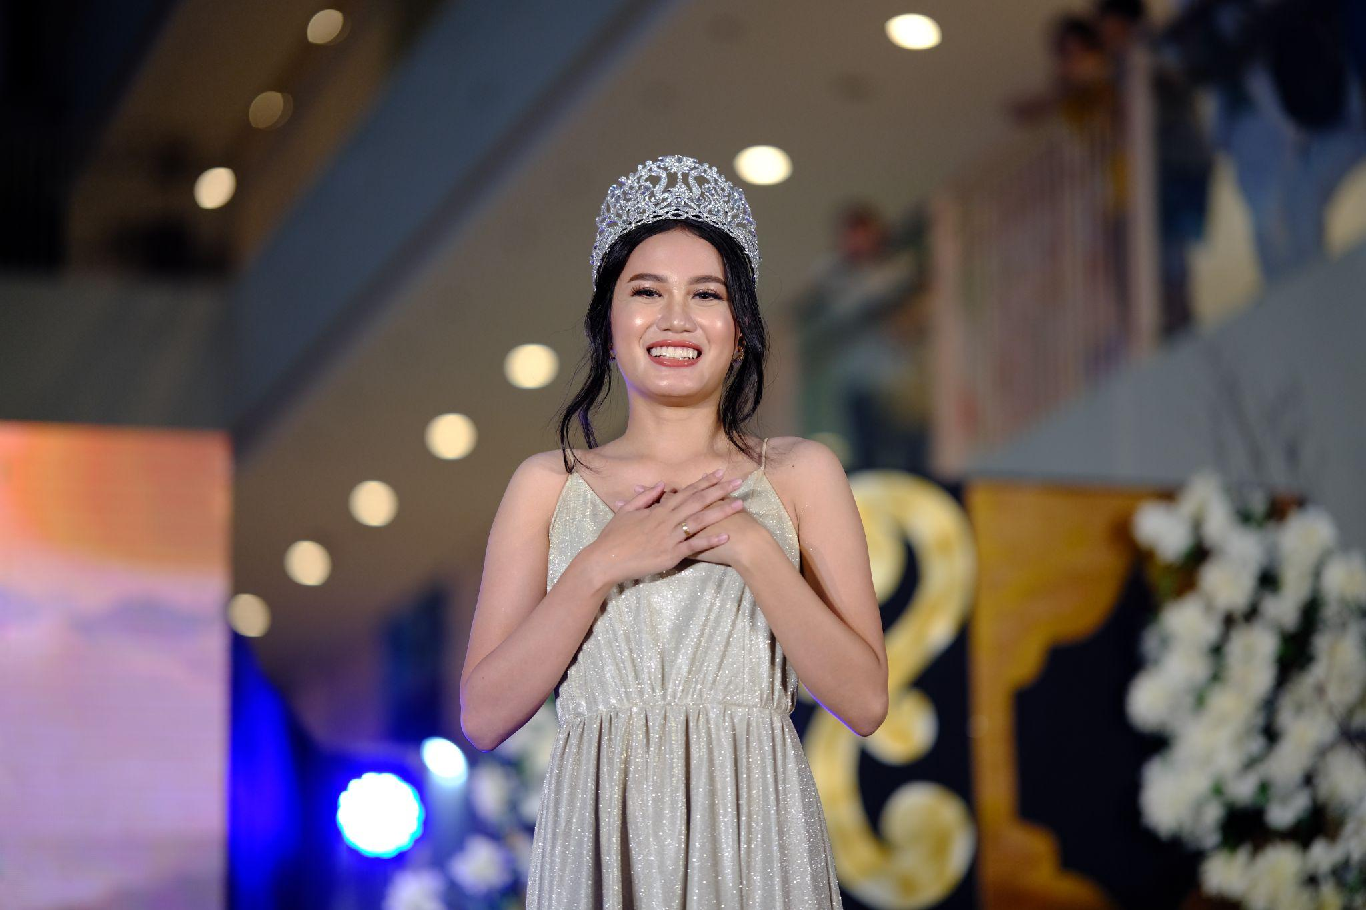

**Mr. and Ms.College of Science 2024**

**Fujifilm xt30 MKii**

**Her favourite photo during her term as a CSC Photographer**

One of her most memorable experiences was when she joined The Photowalk, a local photography event where enthusiasts explore Bicol through their cameras. It was there that her talent was recognized, leading to an invitation to join Bicolano Litratistas, a respected community of photographers in Region V. Becoming part of this group helped her grow both as an artist and as a person, giving her opportunities to find more gigs, and learn from peers.

Arielle’s photography revolves around street and scenery themes, two genres that allow her to capture life as it naturally unfolds. Where she captures life in its most candid form. Her editing process remains simple. She relies heavily on the film simulation feature of her Fujifilm camera, which allows her to preserve the nostalgic tones she loved back in her early days into the craft.

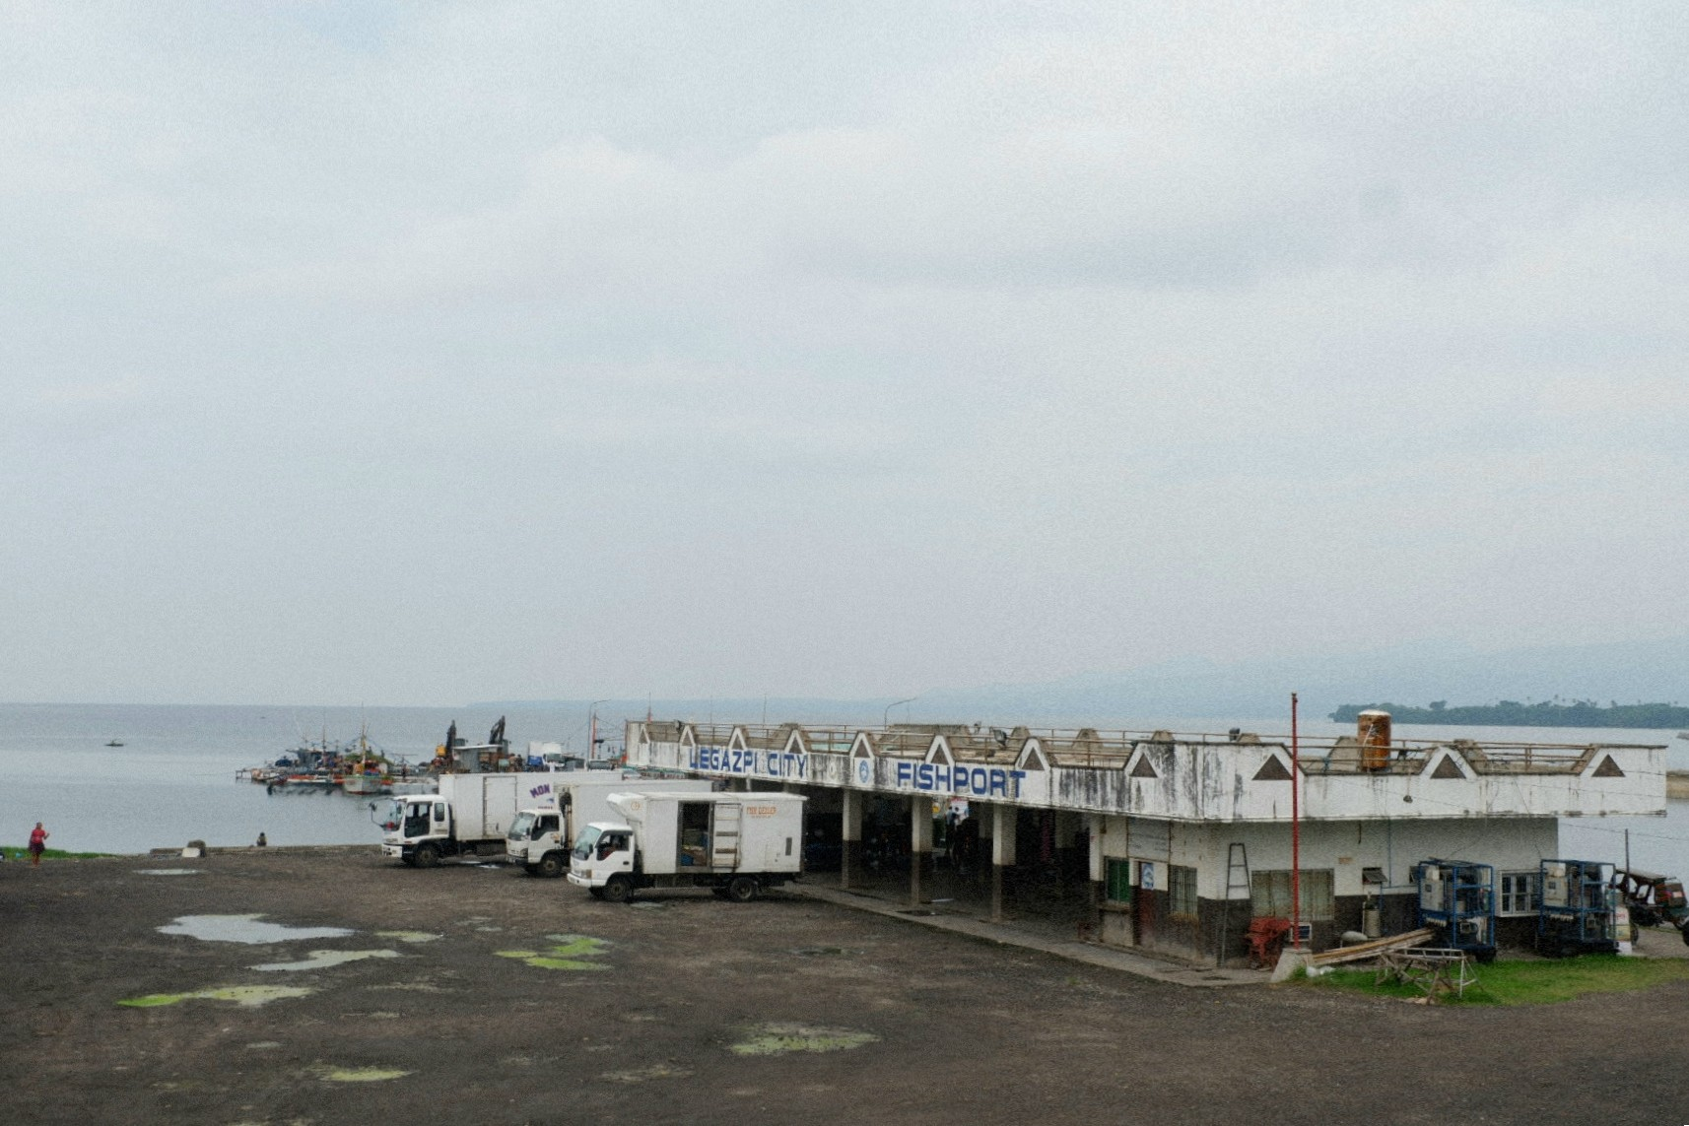

**Legazpi Fish Port 2023**

**Fujifilm xa3**

**Her favorite photo taken during the photowalk.**

"The story behind each image is just as important as the composition itself" she stated. She believes that every photograph should tell a story without needing words, and that story-telling is the core of good photography. Whether it’s a quiet street scene, a sunset by the sea, or a fleeting expression on someone’s face, her goal is to always paint a thousand words.

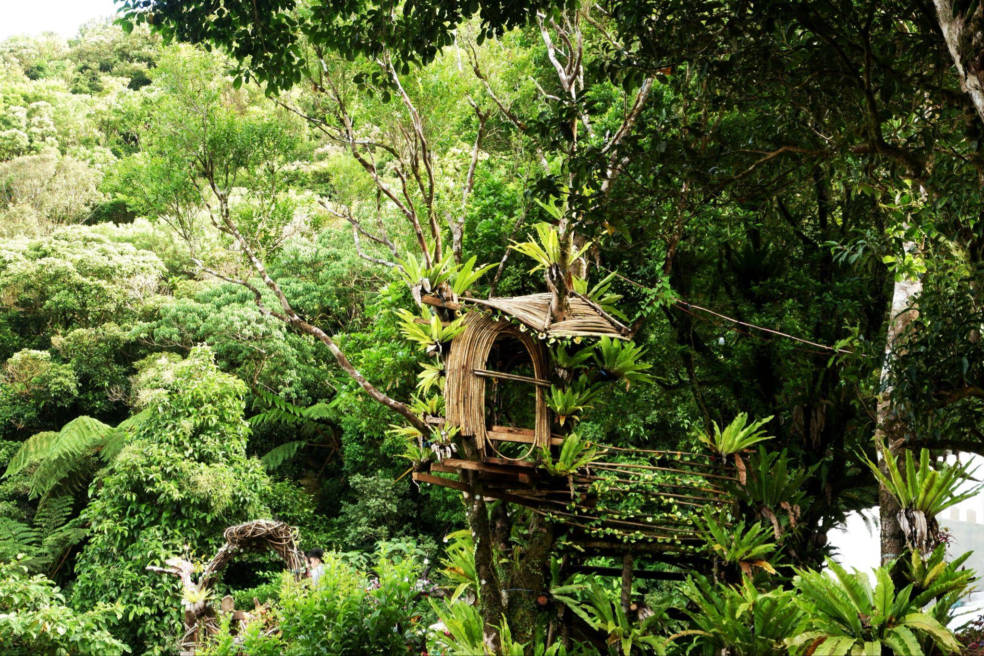

**Zambales 2021**

**Fujifilm xa3**

**This is her go-to entry when applying to photographer communities.**

Like many artists, Arielle has faced her share of challenges along the way. She vividly remembers the time she accidentally broke her camera, which temporarily slowed her down. It was a painful setback, but one that reminded her the true meaning of a photographer. She continued taking pictures using her phone to continue pursuing what she loves. Arielle also struggled with shyness, which made it hard to take photos in public or approach strangers for street portraits.

Beyond those personal hurdles, she admits that post-processing and editing can be overwhelming at times. Tasks like organizing, exporting, and uploading images are tedious compared to the joy of capturing them. Still, Arielle views these challenges as necessary parts of photography. A challenge she's willing to embrace.

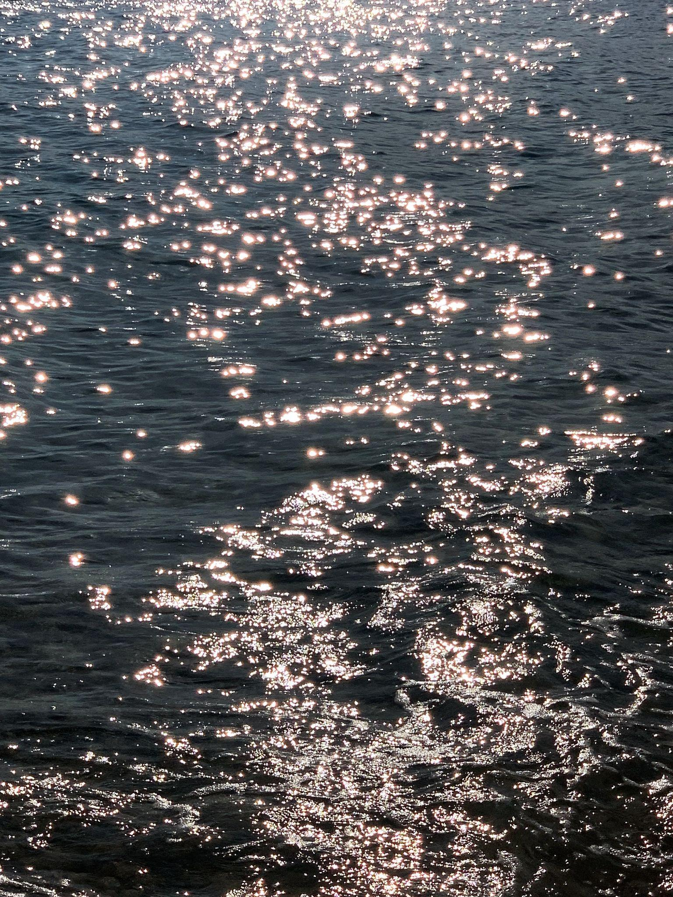

**Visayas, Sambawan Island, 2025**

**Fujifilm X-t30 MKii**

**Sun shines beautifully on her favorite color**

Through her journey, she has learned to appreciate patience and mindfulness. Photography, she says, has trained her to be more observant, noticing the little details that are often overlooked.

For Arielle, photography is more than just a hobby, it’s a way of preserving timeless memories. Every shot becomes a moment she can revisit, a reminder of the beauty she saw.